**File Handling**

Program to Read , Write and Append a file

Output:

1. User entering details to write in a file

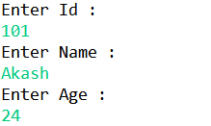

1. The written data’s are stored in the file

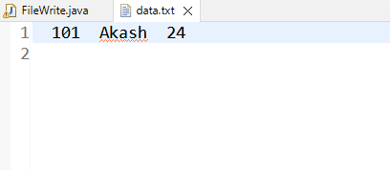

1. User reading the data stored in the file

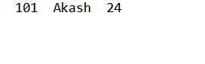

1. User entering the details to append in existing file
2. 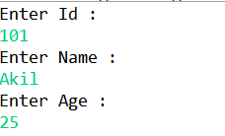File after appended

